Knowledge Extraction from Urban Planning Documents
Final Project Summary Report

1. Introduction
Urban planning documents contain important information about land use, development controls, permit requirements, authorities, and related planning provisions. However, this information is usually stored in long and complex PDF documents, which makes it difficult to access, search, and reuse efficiently. For planners, researchers, and other users, extracting useful planning knowledge from these documents manually can be time-consuming and inconsistent.
This project focuses on the development of a knowledge extraction pipeline for urban planning documents. The aim is to transform unstructured planning text into structured outputs that can be more easily analysed, reviewed, and reused. By converting key planning information into machine-readable formats, the project supports improved access to planning knowledge and provides a foundation for future automation and decision-support applications.
The project began with a rule-based prototype and was later extended with a model-assisted sentence classification approach. Through this process, the project explored both document-processing methods and supervised text classification techniques for extracting structured knowledge from Victorian planning documents.
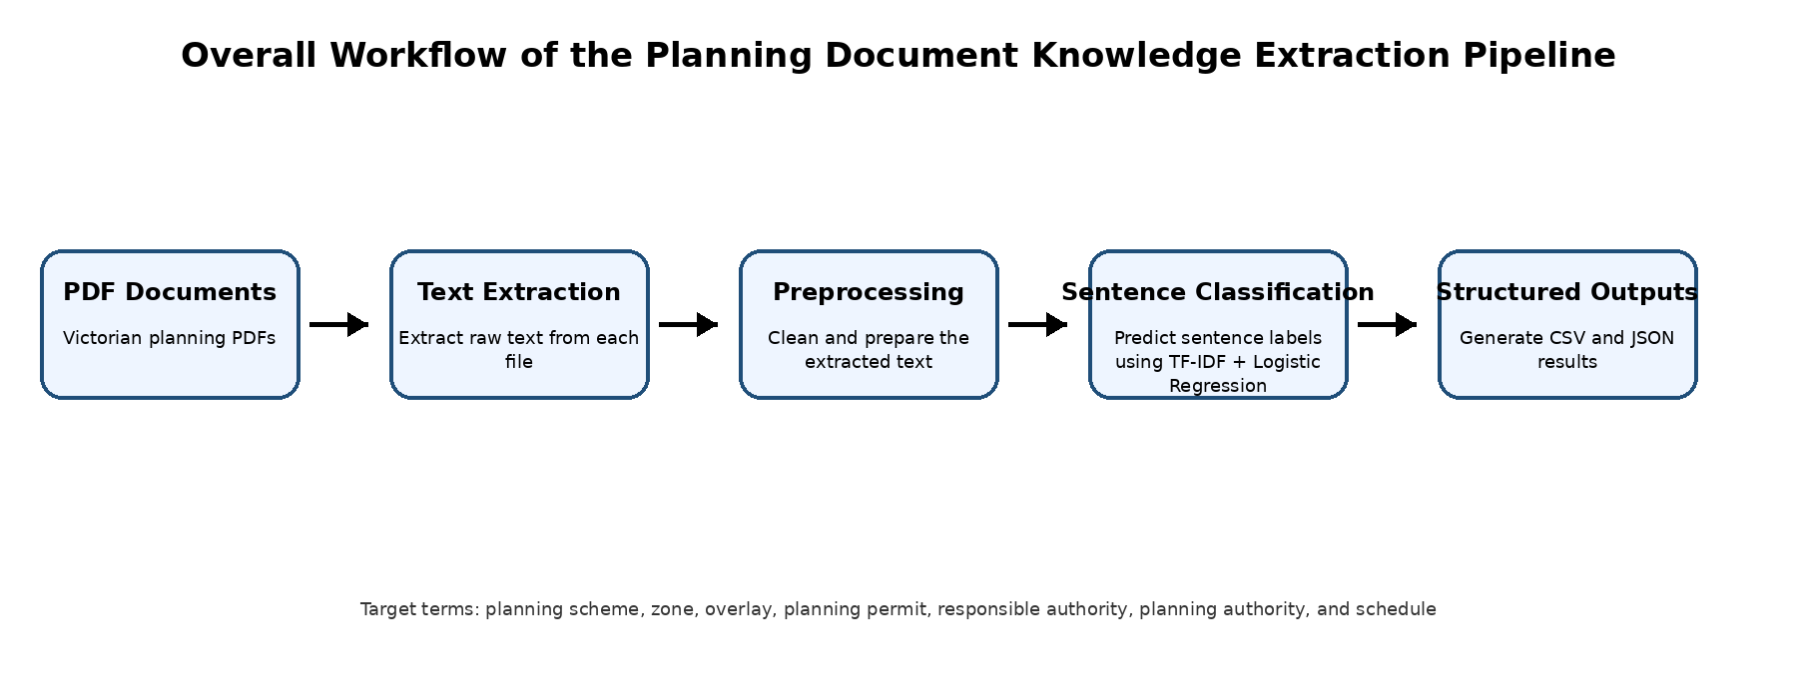Figure 1. Overall workflow of the planning document knowledge extraction pipeline.

2. Project Objective
The main objective of this project is to extract structured planning knowledge from Victorian urban planning documents in PDF format. The project aims to identify and organise important planning information that is normally embedded in unstructured text.
The extraction process focuses on a set of core fields that are useful for planning knowledge representation. These fields include the planning term, its definition, its purpose or function, permit-related information, authority involved, related planning components, and the source section from which the information is extracted.
To achieve this objective, the project develops a pipeline that performs PDF text extraction, text preprocessing, sentence classification, and structured output generation. The final outputs are saved in CSV and JSON formats so that they can be reviewed easily by users and also reused in future system development.
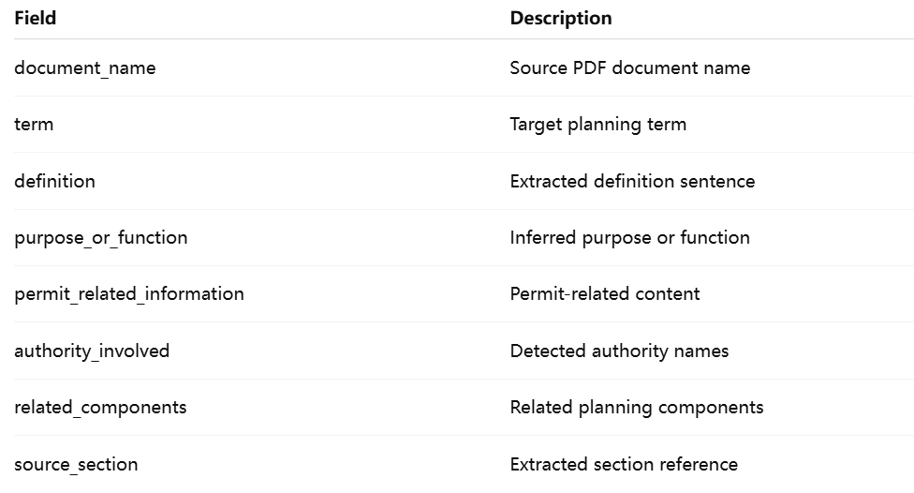Figure 2. Example structure of the extracted output fields.

3. Dataset
The dataset used in this project consists of Victorian planning documents in PDF format. These documents were collected from publicly available planning sources and include planning system guidance materials as well as regional and policy-related planning documents. The documents vary in structure, length, and writing style, which makes the extraction task more challenging.
At the beginning of the project, a smaller set of documents was used to build the initial prototype and test the extraction workflow. Later, the document set was expanded in an attempt to improve model performance by increasing the amount of available text. However, this experiment showed that simply increasing the number of PDF files did not necessarily improve the extraction quality. In several cases, the larger document set introduced more noise and reduced the stability of the results.
Based on this observation, the project placed greater emphasis on improving label quality and extraction logic rather than relying only on larger document volume. This became especially important for improving definition extraction, which remained the weakest part of the system across multiple iterations.

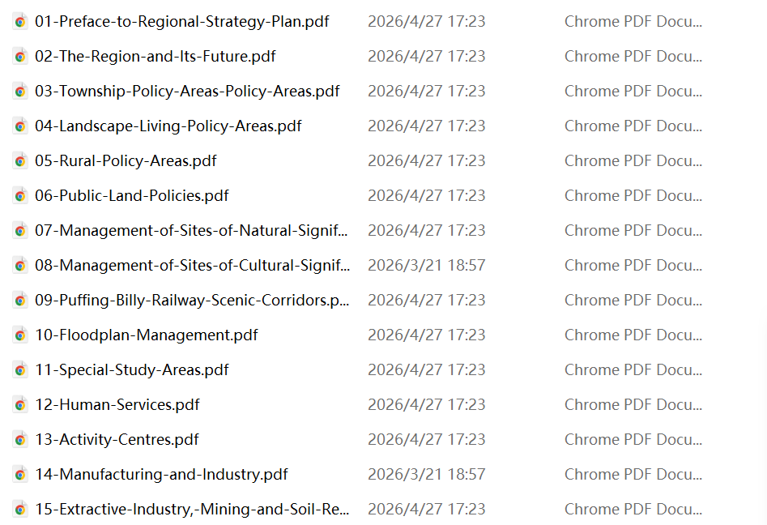Figure 3. Example planning PDF documents used in the project dataset.

4. Methodology

4.1 Initial Rule-Based Prototype
The project initially used a rule-based prototype to extract planning knowledge from PDF documents. In this stage, the workflow focused on converting raw PDF files into text and then applying simple rule-based matching to identify useful planning information. The pipeline first extracted text from each PDF document and stored the cleaned results in intermediate text files. Basic preprocessing was then applied to remove extra spaces, reduce formatting noise, and make the text more suitable for further analysis.
The early rule-based approach relied mainly on keyword matching and predefined target terms such as planning scheme, zone, overlay, planning permit, responsible authority, planning authority, and schedule. This prototype was useful for establishing the overall workflow and generating initial structured outputs. However, the rule-based method was limited because it was sensitive to wording variation and often struggled to identify clear definitions or distinguish between different types of planning sentences.
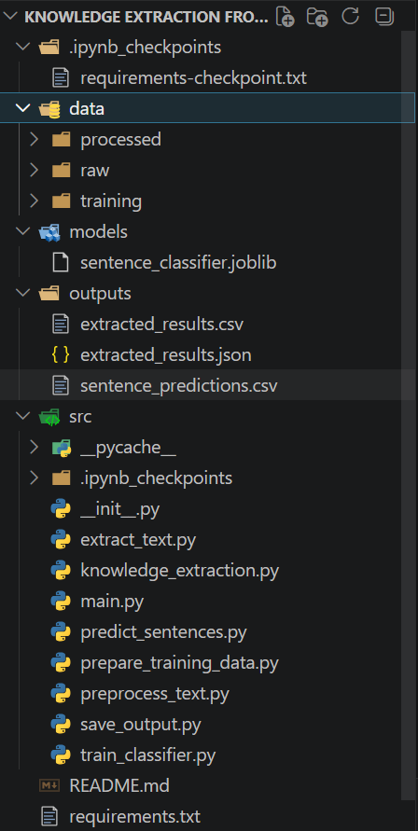
Figure 4. Project structure and main source code modules.

4.2 Model-Assisted Sentence Classification
To improve the extraction pipeline, the project was extended with a supervised sentence classification model. Instead of relying only on direct rule matching, the updated system first split the processed document text into individual sentences and then used labelled training data to classify each sentence into one of five categories: definition, permit_related, authority, component, and other.
The model used in the project was a TF-IDF and Logistic Regression sentence classification model. TF-IDF was used to convert sentence text into numerical features, and Logistic Regression was used as the classifier because it is simple, interpretable, and suitable for a relatively small labelled dataset. This model-assisted approach allowed the system to move beyond purely rule-based extraction and introduced a more structured way of identifying the type of information contained in each sentence.
A labelled dataset was prepared manually for model training. During the project, this labelled data was refined several times, especially after it became clear that weak definition extraction was one of the main limitations of the system.
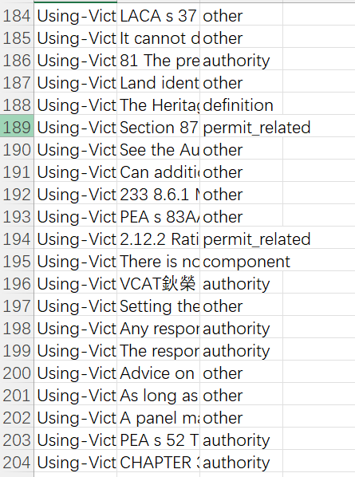
Figure 5. Labelled sentence data used for supervised sentence classification.

4.3 Structured Output Generation
After sentence classification, the predicted sentence labels were used to build structured records for each target planning term. For each document, the system searched for sentences associated with a target term and then selected candidate sentences for different output fields, including definition, permit-related information, authority involved, related components, and source section.
The extracted information was then organised into structured records, with each row corresponding to a planning term within a document. These results were saved in both CSV and JSON formats. The CSV output provided a convenient table for manual review, while the JSON output provided a machine-readable version suitable for future system use.
In addition, the project also saved sentence-level prediction results in a separate CSV file. This intermediate output was helpful for checking how the classifier was performing and for understanding why some final extraction fields were strong while others remained weak.
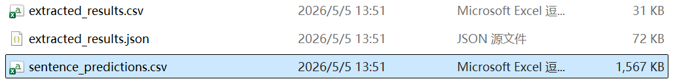
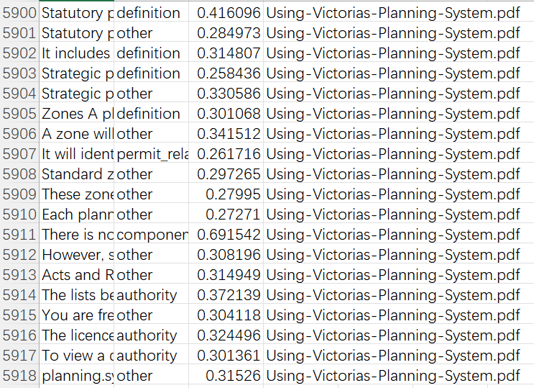
Figure 6. Sentence-level prediction output used for structured extraction.

4.4 Post-Processing Improvement
After reviewing the model outputs, it became clear that the main weakness of the system was still definition extraction. In many cases, the model selected noisy sentences, procedural explanations, or weak descriptive matches instead of cleaner definition-like sentences. Simply increasing the number of PDF documents did not solve this problem.
To address this issue, the post-processing stage was improved by refining knowledge_extraction.py. The sentence selection logic was updated so that more definition-like sentences could be prioritised when building the final structured records. Custom scoring rules were introduced to reward sentences containing stronger definitional patterns, such as “what is”, “is a”, “is an”, and other clearer explanatory wording. At the same time, penalties were applied to noisy candidates such as chapter headings, page fragments, figure references, or overly long procedural text.
This refinement made the post-processing stage more selective and helped improve the final output quality for several important planning terms. As a result, the later model iterations showed more useful results for terms such as planning scheme, planning authority, planning permit, and overlay, although weaker terms such as zone, schedule, and responsible authority still required further improvement.
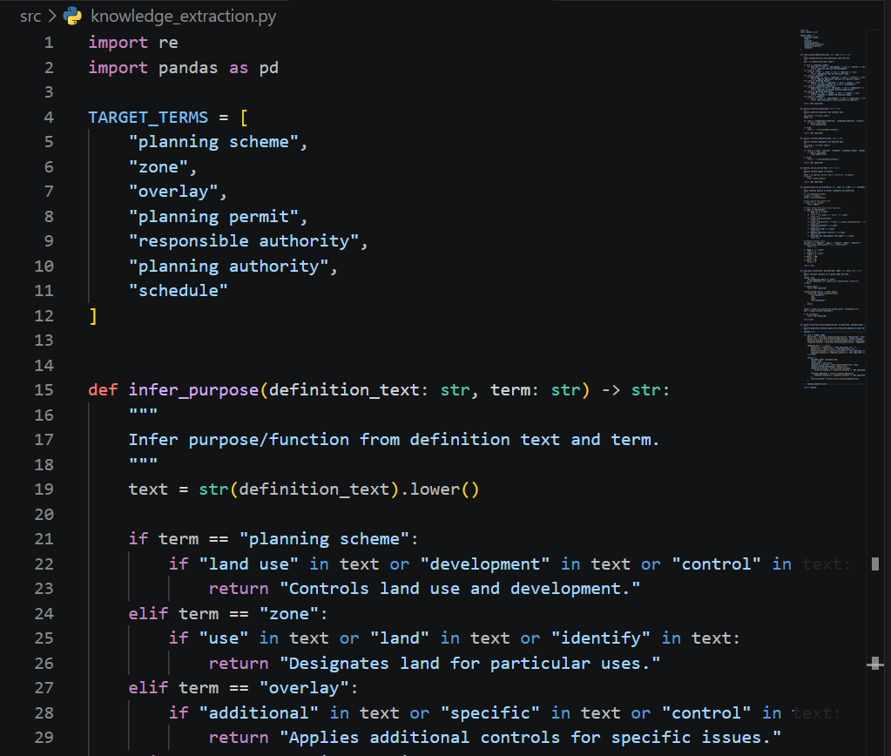
Figure 7. Updated post-processing logic for selecting higher-quality definition sentences.

5. Results and Discussion

5.1 Initial Baseline Results
The initial rule-based prototype provided a useful starting point for the project by demonstrating that structured planning information could be extracted from PDF documents and saved into organised output files. The prototype was able to detect some target terms and produce basic structured records, particularly when the wording in the documents closely matched the predefined rules.
However, the early outputs also showed several limitations. Many extracted fields were incomplete, and definition-related information was often missing or inconsistent. In a number of cases, the system matched a sentence that contained the target term but did not provide a clear definition or useful planning explanation. This showed that simple rule matching was not sufficient for more complex planning documents, especially when the wording varied across documents.
These early observations motivated the transition from a purely rule-based approach to a model-assisted extraction pipeline.
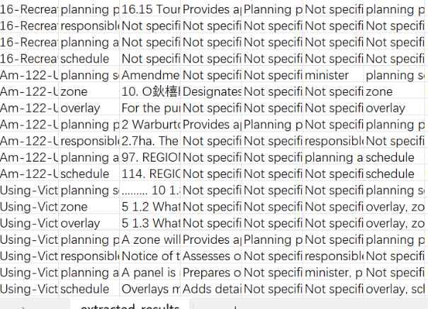
Figure 8. Example of early baseline extraction results.

5.2 Expanded PDF Trial
One of the model improvement attempts involved increasing the number of Victorian planning PDF documents used in the project. The expectation was that a larger document set would provide more text, more examples of planning language, and a stronger basis for extraction.
However, after re-running the pipeline on the expanded document set, the results did not improve as expected. In several cases, the outputs became less stable than the earlier smaller-scale version. The larger document set introduced more variation in structure, writing style, and noise, including documents with less useful content for definition extraction. As a result, broader document coverage did not automatically lead to better extraction quality.
This was an important finding in the project. It showed that increasing document quantity alone was not enough to improve the system. The quality of the labelled examples and the quality of the sentence selection logic were more important than simply having more PDF files.
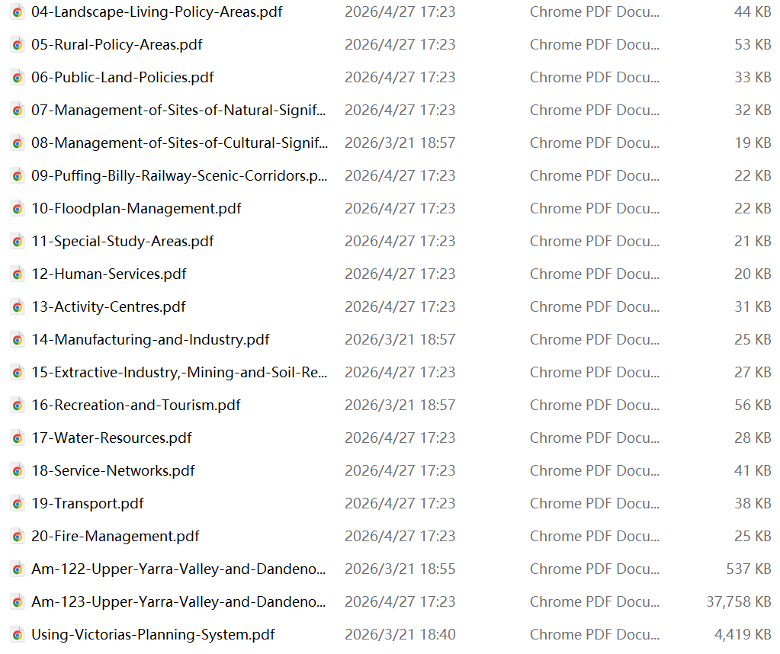
Figure 9. Expanded document set used in the larger-scale extraction trial.

5.3 Label Refinement and Post-Processing Improvement
After reviewing the expanded-data outputs, the project identified weak definition extraction as the main problem. Many terms still returned “Not specified”, while others were linked to sentences that were only loosely related to the target term. This suggested that the classifier and the final extraction logic both needed to be improved in a more targeted way.
To address this, additional effort was placed on improving the labelled training data, especially by adding more definition-focused examples for important planning terms. This was followed by further refinement of the post-processing stage in knowledge_extraction.py, where the sentence selection logic was updated to prioritise more definition-like matches and reduce noisy or less relevant outputs.
This combination of label refinement and post-processing improvement produced moderate improvement in the later outputs. The strongest gains were observed in the main reference document, where terms such as planning scheme, planning authority, planning permit, and overlay became more useful than in earlier iterations. For example, the system was more likely to extract sentences that were closer to definition-style explanations instead of unrelated procedural text.
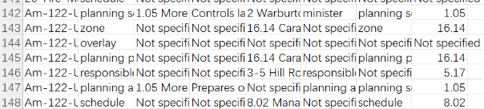
Figure 10. Improved extraction outputs after label refinement and post-processing updates.

5.4 Current Performance Summary
At the current stage, the project has produced a working model-assisted knowledge extraction prototype. The system is able to process planning PDFs, classify sentences, and generate structured outputs in CSV and JSON formats. The most useful outputs were obtained for terms such as planning authority, planning permit, planning scheme, and overlay, particularly in the main reference document.
At the same time, the results also show that performance is still uneven across documents and terms. Some documents still produce sparse outputs, and several terms remain weak. In particular, zone, schedule, and responsible authority continue to be less stable than the stronger terms. In some cases, the system still selects explanatory or procedural sentences instead of clean definitions.
Overall, the results show that the project has moved beyond a simple rule-based prototype and successfully developed a model-assisted extraction pipeline. The later improvements also show that targeted refinement of labels and extraction logic can be more effective than simply increasing the size of the document collection.
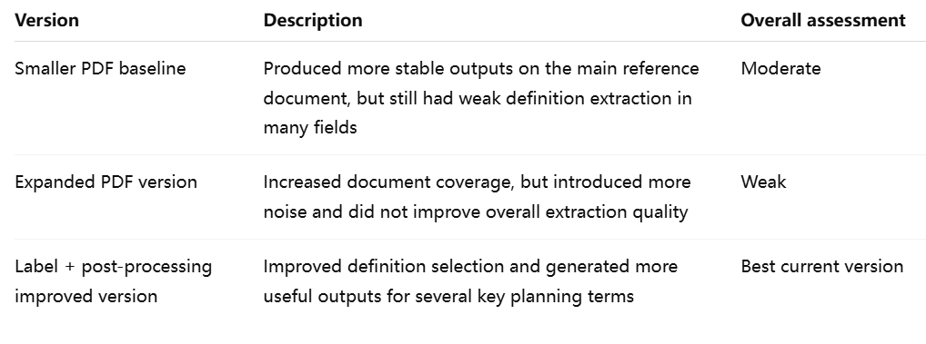Table 1. Summary of extraction quality across major project iterations.

6. Limitations
Although the project successfully developed a model-assisted knowledge extraction pipeline for urban planning documents, several limitations remained at the final stage. The most important limitation was the inconsistency of definition extraction. While some planning terms could be extracted with moderate success, many results still returned “Not specified” or selected description-like sentences rather than clean and direct definitions.
Another limitation was the uneven performance across documents. The extraction quality was better in the main reference document, where planning terms were explained more clearly, but weaker in many other documents that contained more complex formatting, fragmented sentences, or less explicit explanatory text. This reduced the consistency of the overall output.
The project also showed that increasing the number of PDF documents did not automatically improve the model results. In practice, larger document volume introduced additional noise and made extraction more difficult. This highlighted the importance of label quality and post-processing logic over simple dataset expansion.
In addition, the current model was based on TF-IDF and Logistic Regression, which provided a simple and interpretable baseline but also limited the system’s ability to capture more complex contextual meaning. As a result, the final system should be understood as a functional prototype rather than a fully robust planning knowledge extraction solution.

7. Conclusion
This project developed a knowledge extraction pipeline for Victorian urban planning documents and transformed unstructured PDF text into structured outputs in CSV and JSON formats. The system was designed to extract important planning information, including term definitions, permit-related information, authorities involved, related planning components, and source sections.
The project began with a rule-based prototype and was later extended with a supervised sentence classification model using TF-IDF and Logistic Regression. Through multiple iterations, the project explored the effects of changing document quantity, improving training labels, and refining post-processing logic. One of the most important findings was that simply increasing the number of PDF documents did not improve the results. Instead, targeted improvements to definition labels and sentence selection logic were more effective in strengthening the quality of extraction.
At the final stage, the project produced a working model-assisted prototype that showed moderate success for several key planning terms, especially planning authority, planning permit, planning scheme, and overlay in the main reference document. Although the extraction quality remained uneven and some terms were still weak, the project demonstrated a complete and reproducible workflow for planning document knowledge extraction. Overall, the project established a practical baseline system and provided a clear example of how structured planning knowledge can be extracted from complex government documents.

